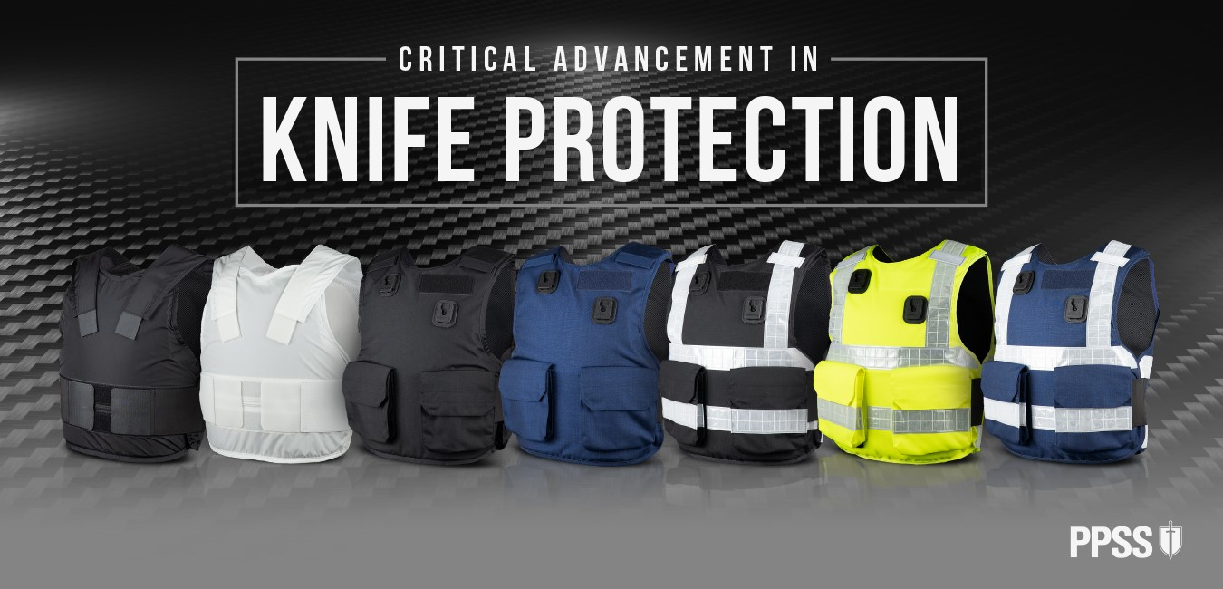

PPSS Group: Critical Advancement in Knife Protection
PPSS Group is replacing its highly acclaimed polycarbonate based stab resistant body armour.
Based on our comprehensive understanding of the changes in today’s most realistic operational risks and threats, we believe an even stronger and even more dependable raw material was required to effectively safeguard those who protect us, our country and infrastructure.
Its lack of certified spike protection resulted in it simply becoming ‘morally’ difficult for us. We, at PPSS Group, all agreed that our international friends and customers rightfully demand even higher levels of protection.
After years of R&D and considerable financial investments, we concluded that carbon fibre composites are ‘the future’, and the only real reliable and forward-thinking long term solution.
Carbon fibre offers far superior levels of stab protection alongside substantial weight reduction and reduced thickness, and finally also fully certified spike protection… at an even better price.
It offers thoroughly field-tested and dependable protection from even the most horrendous looking knives, machetes, razor blades, shanks and indeed spikes.
The following comparison chart is highlighting some rather impressive facts:
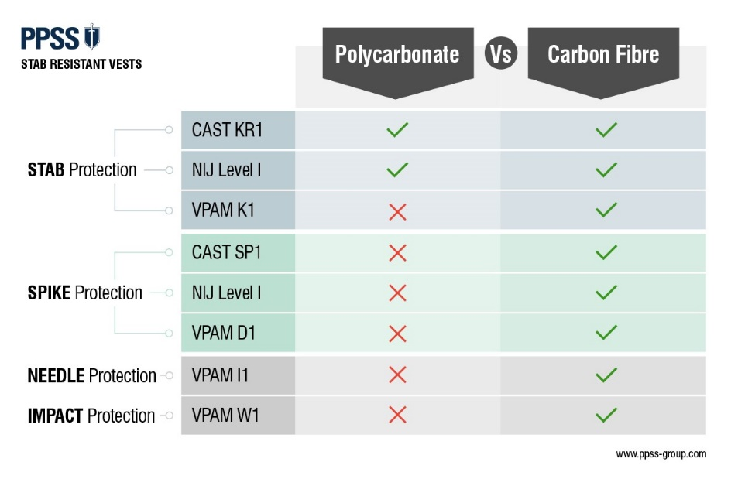
Certified spike protection is crucial, especially to correctional and prison officers who tend to face some of the cruellest makeshift weapons, such as shanks and spikes on a daily basis.
However, spike protection has now also become of equal importance to all homeland and private security professionals, simply due to the type of weapons appearing on the streets in recent years.
Our latest body armour will offer VPAM I1 ‘Needle Protection’ and VPAM W1 ‘Impact Protection’ which provides additional peace of mind, preventing internal injuries and bleeding when assaulted by blunt objects.
We know, over the past ten years, PPSS Group’s high-performance body armour have been offering the most reliable levels of protection from edged weapons, effectively protecting homeland and private security professionals worldwide.
Our product videos, which feature me personally being subjected to all types of attacks using some of the most horrific edged weapons have long been regarded as ‘physical evidence’ of its ‘real-life’ performance and quality.
You can trust them… I most certainly do: https://www.youtube.com/watch?v=BtE2BrJrKLo
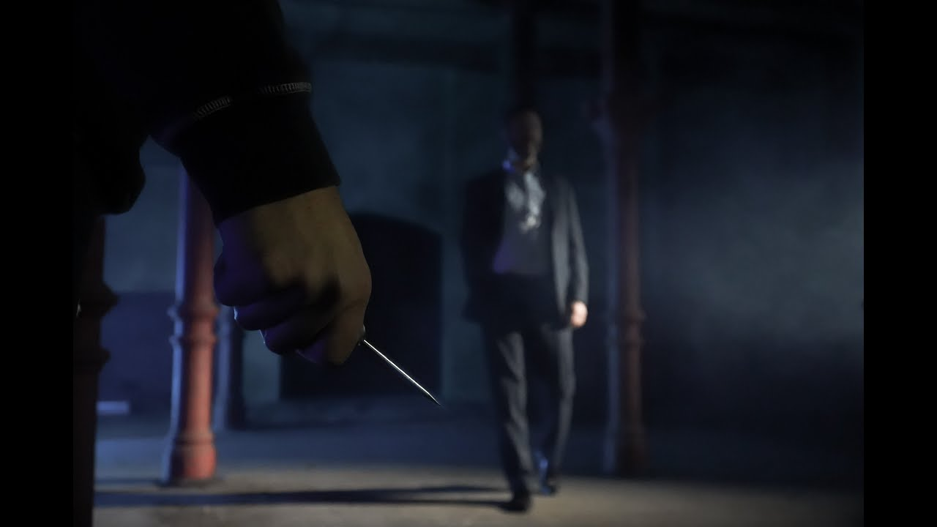
PPSS Stab Resistant Body Armour: Performance Levels
- CAST Body Armour Standard (2017) KR1/SP1 (Stab & Spike)
- NIJ Standard 0115.01 NIJ Level 1 (Stab & Spike)
- VPAM KDIW 2004 (18.05.2011) VPAM K1 (Stab & Spike)
- VPAM KDIW 2004 (18.05.2011) VPAM I1 (Needles)
- VPAM KDIW 2004 (18.05.2011) VPAM W1 (Blunt Trauma)
The reason why we have decided to create a ‘new generation’ of stab resistant body armour lies in the recent changes of today’s society.
Looking especially at Western Europe and many other regions, we have to accept that religious extremism, terrorism, social deprivation, immigration and a general breakdown in society have all contributed to the increasing number of edged weapons being carried, but also the types of edged weapons actually being used.
Today we see truly evil people walking the streets, carrying ‘Samurai’ swords, meat cleavers and machetes with 60cm (24”) long blades, brutally chopping people into pieces in rage or driven by extremism, often committing multiple homicide or mass murder in the process.
In this video I briefly explain and emphasise why we have replaced our polycarbonate-based model with our new high performance carbon fibre model: https://www.youtube.com/watch?v=JDYkgCqw_3Q
Why do we see such clear change from firearms to edged weapons? Why are so many Terrorists and Extremists and other seriously dangerous people choosing ‘blades’ as their favourite weapon of choice?
- In most countries guns are illegal. Selling or buying firearms, exporting or importing firearms, carrying or transporting them comes with a real risk these days. Due to the threat of global terrorism, Intelligence Services and Law Enforcement Agencies around the world keeping a very close eyes on everything metal that fires rounds aiming to kill people. The risk of being ‘picked up’ prior to a planned attack is just too high. Due to stringent firearm controls in Europe and other regions, and the low planning required to conduct a knife attack whether against an individual or mass group), knives have recently and most certainly become the weapon of choice for many so called “lone-wolf” attackers. Edged weapons are simply easily accessible.
- Criminals of all types prefer to hide their weapons until the moment they decide to take action. The desire of people to want to conceal their weapon is partly based on the fact that it is a crime in many countries to carry an offensive weapon and they wish to avoid detection an arrest. Edged weapons are easier to conceal than a firearm.
- ‘No training required’. To purchase a firearm is one thing. To fire a gun and hitting a potentially moving target from a reasonable distance and avoid identification and arrest is a completely different matter altogether. To use a knife or any other ‘blade’ does not require any training. Edged weapons are easy to use.
If you wish to find out more about why we can identify a clear overall increase in knife crime, please read my article: “Global Rise of Knife Crime – Why?”
For our dedicated ‘products’ page, please visit: www.ppss-group.com/stab-resistant-vests/
Please be assured, PPSS Group can effectively help you protect your workforce, by simply offering them the most appropriate levels of protection they require when dealing with the most realistic risks and threats of today’s society.
In case if you have any questions about our ‘new generation’ of stab resistant body armour, please leave a comment or email my team info@ppss-group.com

Stay Safe.

Robert Kaiser, Founder & CEO
PPSS Group

*for both the OVERT and HI VIZ OVERT model

