Ray Wheatley
Security Services Manager of Dublin City University

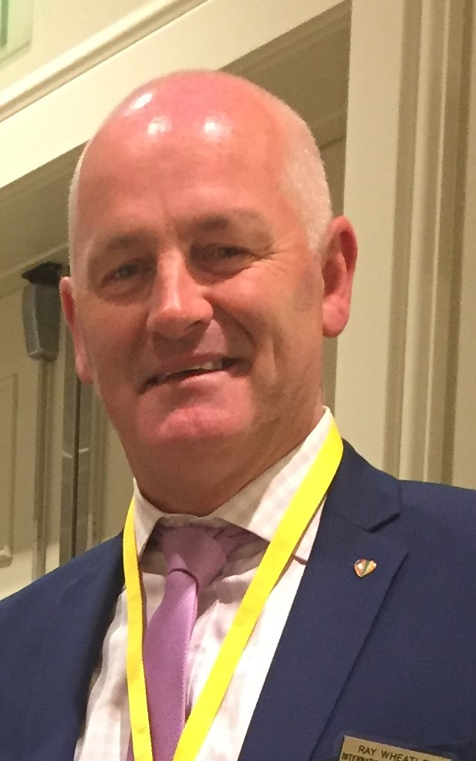
Ray Wheatley has worked in the Security Industry for the past 22 years. In 1995 he was appointed Security Services Manager of Dublin City University, Ireland. Ray has been an executive member of the Association of University Chief Security Officers for the past 10 years and hosted the International Conference on Campus Security at Dublin City University in 2004. In 2005 Ray was short listed as for the Security Manager of the Year in the United Kingdom. He has various qualification is security training Security Training and is a member of the Security Institute of Ireland from which he graduated with a Diploma in Security Management in 2008. He is also the International representative for AUCSO (European Association of University Chief Security Officers) Ray has been a very active member of International Association Campus Law Enforcement Administrators since 2002 and was appointed International Director in autumn of 2011. Ray is also the regional Director for the Irish Security Managers of Higher Education.

Ray is a strong believer in leading from the front!

